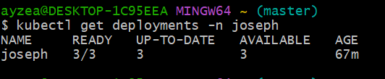

Describe Deployment:
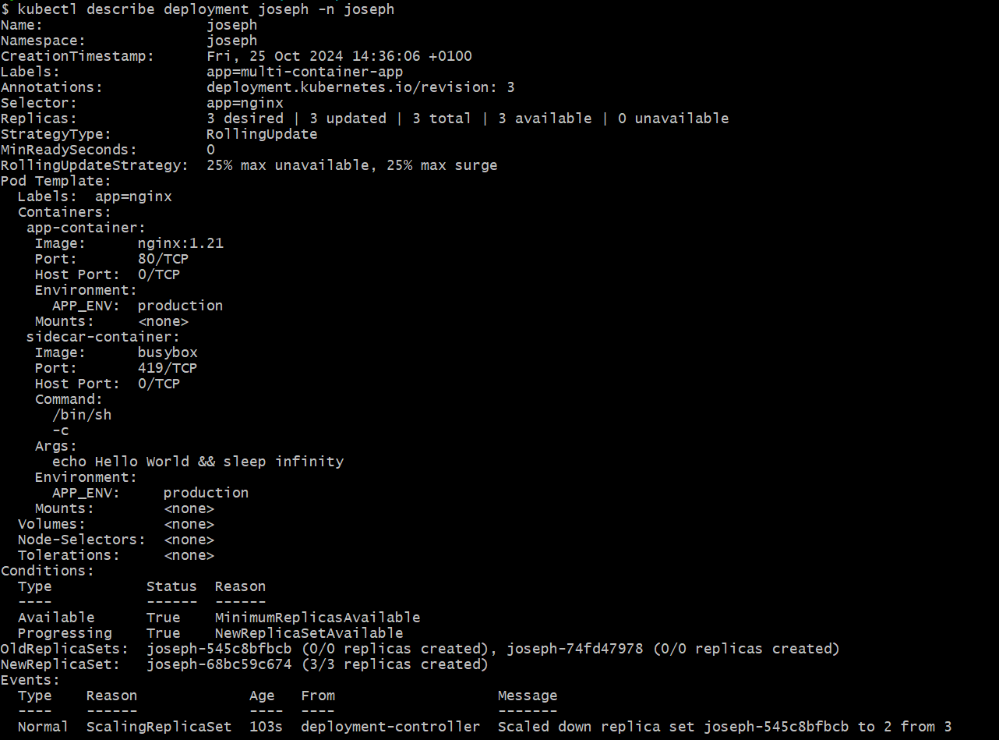 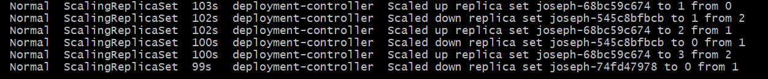

Get pods
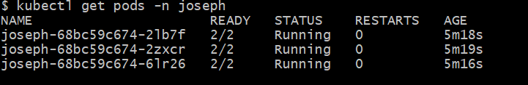

To Create Service to expose the Deployment;
